SECTION 01

TITLE: Land thoughtfully planned for the future.
SUBHEADING: Upscale Properties creates thoughtfully planned plotted developments in high-potential locations, combining strategic planning, transparency, and long-term value.

BUTTON: EXPLORE PROJECTS

CARD ON RIGHT:

Investment-led thinking
Thoughtful land development

SECTION 02
A plot is more than a piece of land. It is the beginning of a home, an investment, and a future.
At Upscale Properties, we develop plotted communities with a long-term perspective, bringing together strategic locations, thoughtful planning, and the confidence that comes from making informed decisions.

SECTION 03

Card 01

Strategic Locations
We look beyond today's demand to identify locations with strong potential for tomorrow.

Card 02

Thoughtful Planning
Every development is planned around connectivity, infrastructure, accessibility, and future growth.
Card 03

Long-Term Value
We create developments with a focus on enduring value, not short-term opportunity.

SECTION 04

25+
Years of Financial & Investment Expertise

2+
High-Potential Cities

ONE LINER RUNNING: Built around the value of a better investment.

DELETE THESE CARDS AFTER ONE LINER (SHOWN BELOW)


THIS SECTION NOT NEEDED:
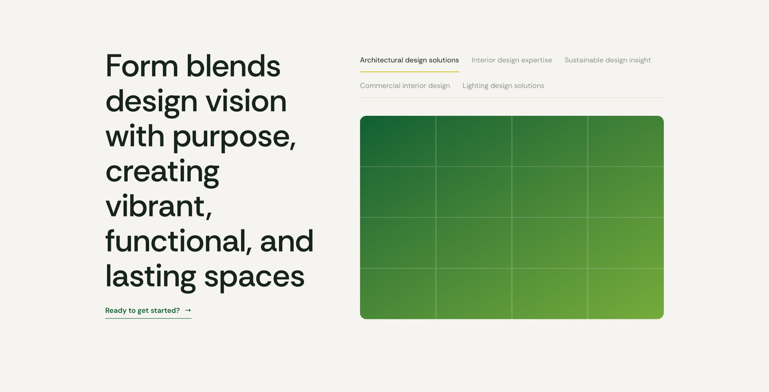

MEET THE TEAM:
VENU GOPAL A (FOUNDER & MANAGING DIRECTOR AT FINQUEST)
MURALI SHASTRI (JOINT PARTNER AT VISHWA PROJECTS)
DELETE THIRD CARD, ONLY 2 NEEDED.

THIS SECTION IS NOT NEEDED:

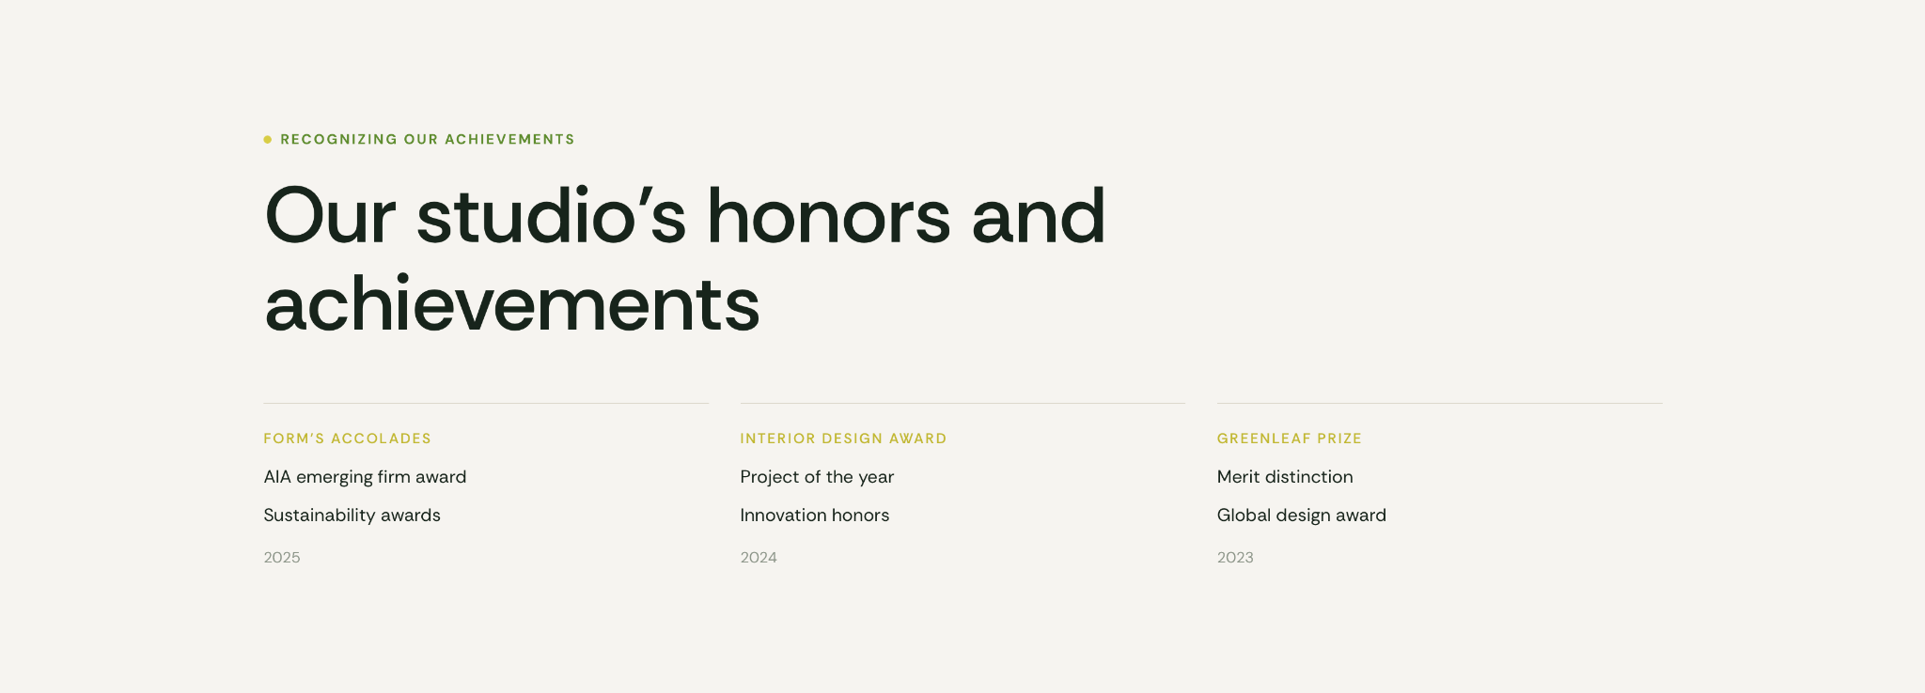

HAVE A CONTACT FORM HERE INSTEAD OF THIS:



Content for Content Form:

Let’s Find Your Next Investment
Have a project in mind or looking for the right plot?
Tell us what you’re looking for, and our team will get in touch.
Form Fields:
Name
- Phone Number
- Email Address
- City / Location
- Investment Requirement
- Message
CTA: Get in Touch

Footer:

Upscale Properties:
Upscale Properties is a plotted development company focused on creating well-planned land opportunities designed for long-term value, growth, and confident investment. With a strong understanding of the investment landscape, we bring clarity and trust to every plot we develop.

Rest of the information will be given once the client shares.

